1. Session breakdown
1. Learning from Data
Hypothesis spaces, training data, overfitting and generalization
2. Decision Trees
Entropy, Gini impurity, information gain and pruning
3. Statistical Learning Theory
PAC learning, VC dimension and model complexity
4. Supervised Learning and Estimation
Supervised learning, MLE and MAP estimation
5. Naïve Bayes Variants
Gaussian, Multinomial and Bernoulli Naïve Bayes
6. Expectation-Maximization
E-step, M-step and the Gaussian mixture example
7. Unsupervised Learning and Evaluation
Clustering methods and evaluation metrics

Topic 1: Learning from Data
The diagram summarizes the complete flow:
Data → ML Model → Prediction
- Hypothesis: One possible model.
- Hypothesis space: All possible candidate models.
- Generalization: Performs well on unseen data.
- Overfitting: Fits training data well but performs poorly on unseen data.

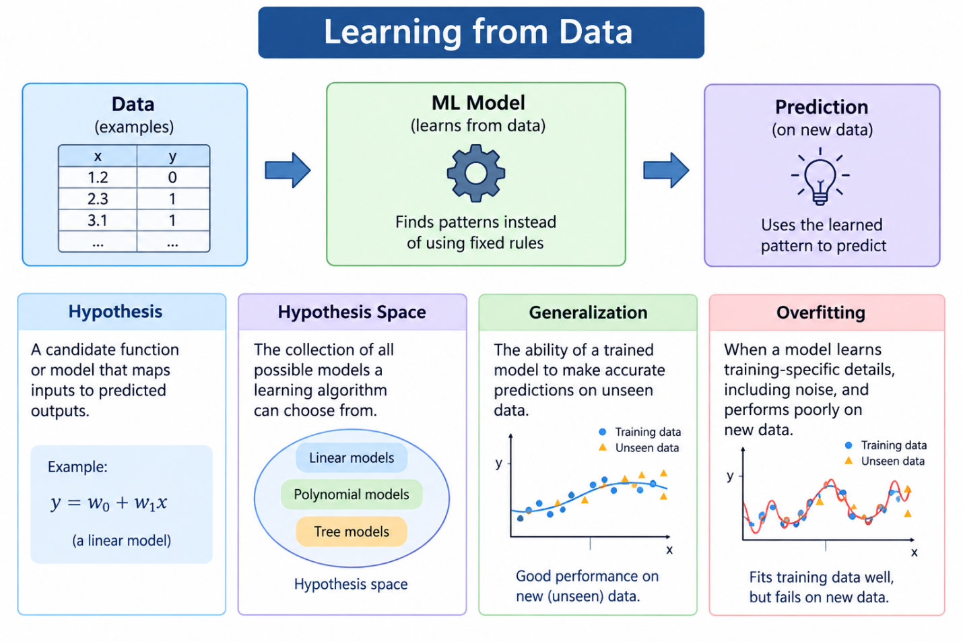
- Learning from data: An ML model identifies patterns from examples instead of relying only on explicitly programmed rules.
- Hypothesis: A candidate function or model that maps inputs to predicted outputs.
- Hypothesis space: The collection of possible models a learning algorithm can choose from.
- Generalization: The ability of a trained model to make accurate predictions on unseen data.
- Overfitting: When a model learns training-specific details, including noise, and performs poorly on new data.

Topic 2: Decision Trees
Decision trees make predictions by repeatedly splitting data using feature-based conditions.

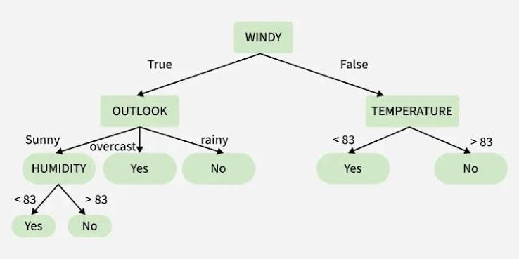
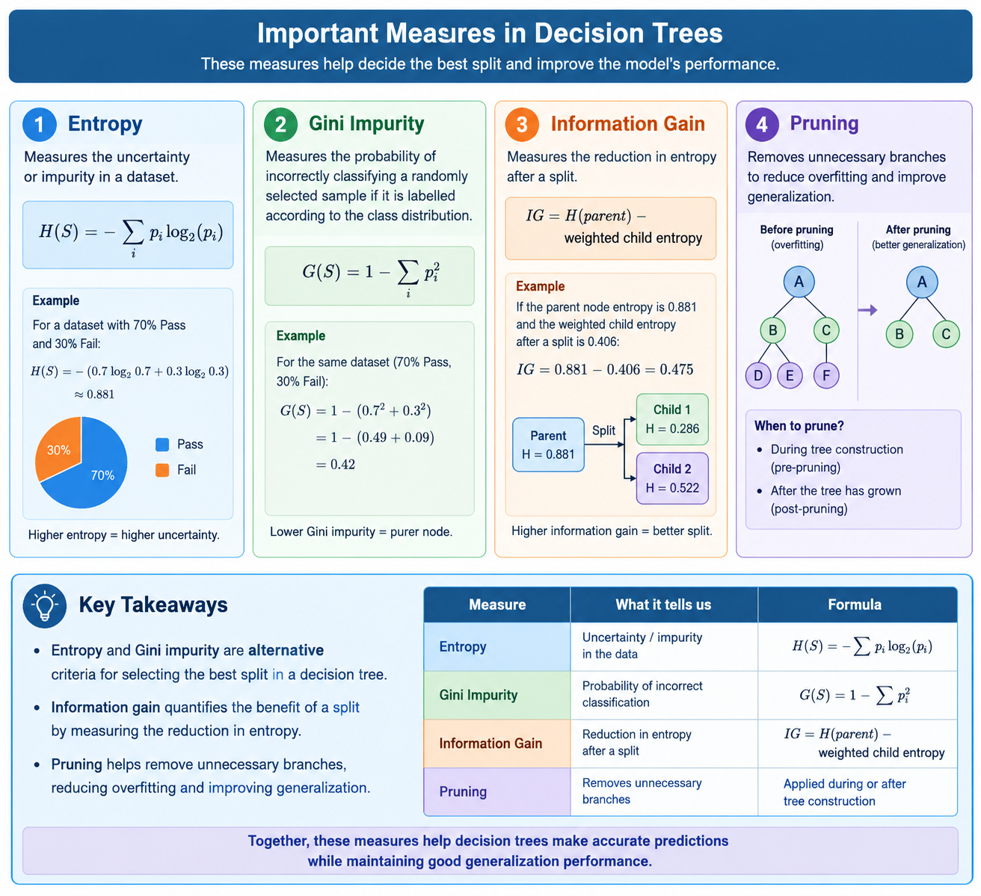
- Entropy: How uncertain?
- Gini: How impure?
- IG: How much uncertainty is reduced by a split?
- Pruning: Which branches can be removed?

Topic 3: Statistical Learning Theory
- Statistical learning theory: Studies how well a model learns from finite training samples and performs on unseen data.
- PAC learning: Probably Approximately Correct learning; a framework for analysing whether a model can learn a sufficiently accurate hypothesis with high probability.
- VC dimension (Vapnik–Chervonenkis Dimension): Measures the expressive capacity of a hypothesis class through the maximum number of points it can shatter.
- What does shatter mean?
A set of points is shattered if the model can correctly classify those points in every possible binary labelling arrangement.
For example, with 3 points, there are 2^3=8 possible ways to assign positive and negative labels. A hypothesis class shatters those points if it can represent all 8 labellings.
- Model complexity: More complex models can represent more patterns but may require more data to generalize reliably.
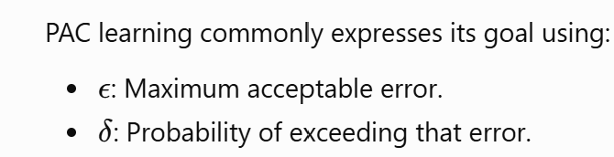
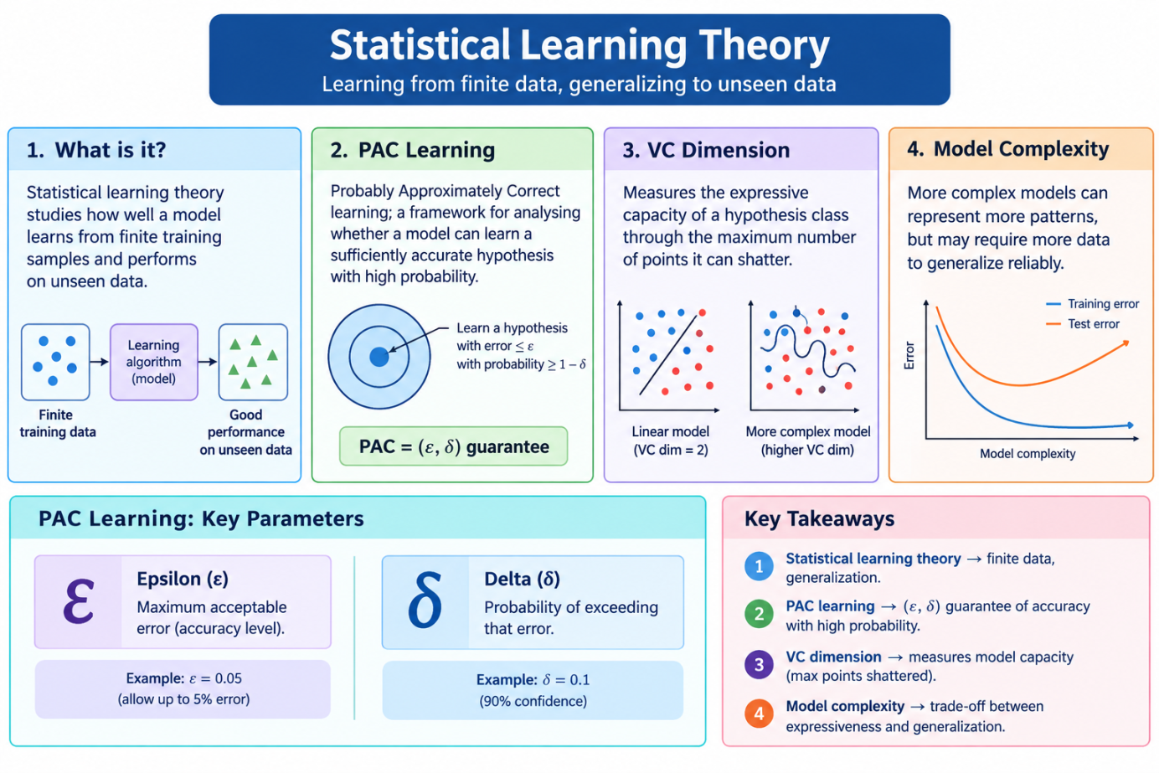

Topic 4: Supervised Learning, MLE and MAP Estimation
- Supervised learning: Learns from labelled input-output examples.
- Maximum Likelihood Estimation (MLE): Estimates model parameters by maximizing the likelihood of the observed data.
- Maximum A Posteriori (MAP) estimation: Estimates parameters by maximizing the posterior probability, combining the likelihood with a prior.
- Example: Estimate the probability of a student passing an examination using observed results. MLE uses the observed pass/fail outcomes; MAP can also incorporate a prior belief about the pass probability.

Comparison table
Feature | MLE | MAP
Full form | Maximum Likelihood Estimation | Maximum A Posteriori
Data used | Observed data | Observed data and prior
Objective | Maximize likelihood | Maximize posterior probability
Prior knowledge | Not explicitly included | Included through a prior
Result | Most likely parameter given the data | Most probable parameter given the data and prior

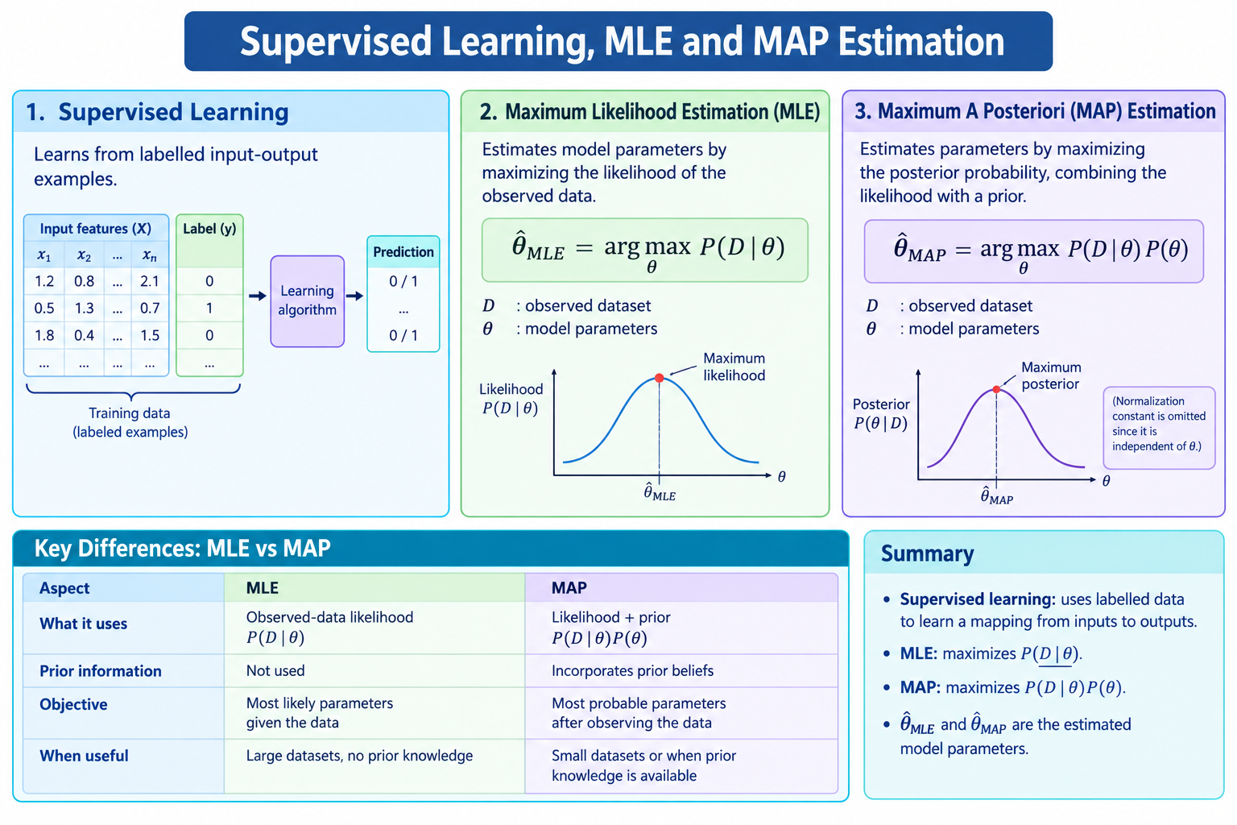

Topic 5: Naïve Bayes Variants
Naïve Bayes is a probabilistic classifier based on Bayes' theorem and the assumption that features are conditionally independent given the class.
Three major variants
Variant | Suitable data | Example
Gaussian Naïve Bayes | Continuous features | Height, temperature
Multinomial Naïve Bayes | Counts or frequencies | Word counts in documents
Bernoulli Naïve Bayes | Binary features | Word present or absent

Topic 6: Expectation-Maximization
Expectation-Maximization (EM) is an iterative algorithm for estimating model parameters when data contains hidden or latent variables.

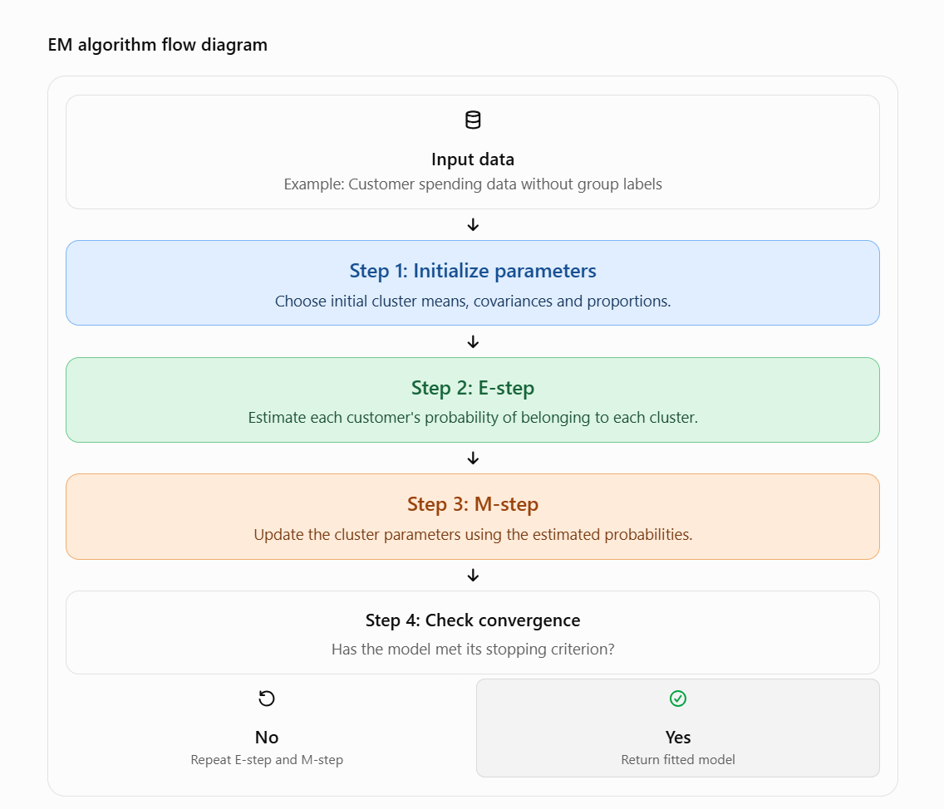

Example: Customer segmentation
Suppose a retail company has customer spending data but does not know which customer belongs to which group.
- E-step: Estimate the probability that each customer belongs to the low-, medium- or high-spending cluster.
- M-step: Update the cluster means, covariance matrices and proportions using those probability estimates.
- Repeat: Continue until the likelihood stabilizes or another stopping criterion is reached.

Topic 7: Unsupervised Learning and Clustering Evaluation
Unsupervised learning discovers patterns in data without requiring labelled target outputs.

Common clustering algorithms
- K-means: Groups observations around cluster centroids.
- Hierarchical clustering: Builds a hierarchy of nested clusters.
- DBSCAN: Identifies dense regions and can mark isolated points as noise.
Clustering evaluation metrics
Metric | Interpretation
Silhouette score | Measures how well a sample fits its own cluster compared with other clusters; higher is generally better
Davies–Bouldin index | Measures average cluster similarity; lower is generally better
Adjusted Rand Index (ARI) | Compares predicted clusters against known reference labels; higher is generally better
- Silhouette and Davies–Bouldin can evaluate cluster structure without ground-truth labels. ARI requires reference labels and is therefore suitable when a labelled benchmark is available.
Classroom example: Group customers according to spending and purchase frequency. Discuss whether the resulting groups are compact, separated and useful for business decisions.
